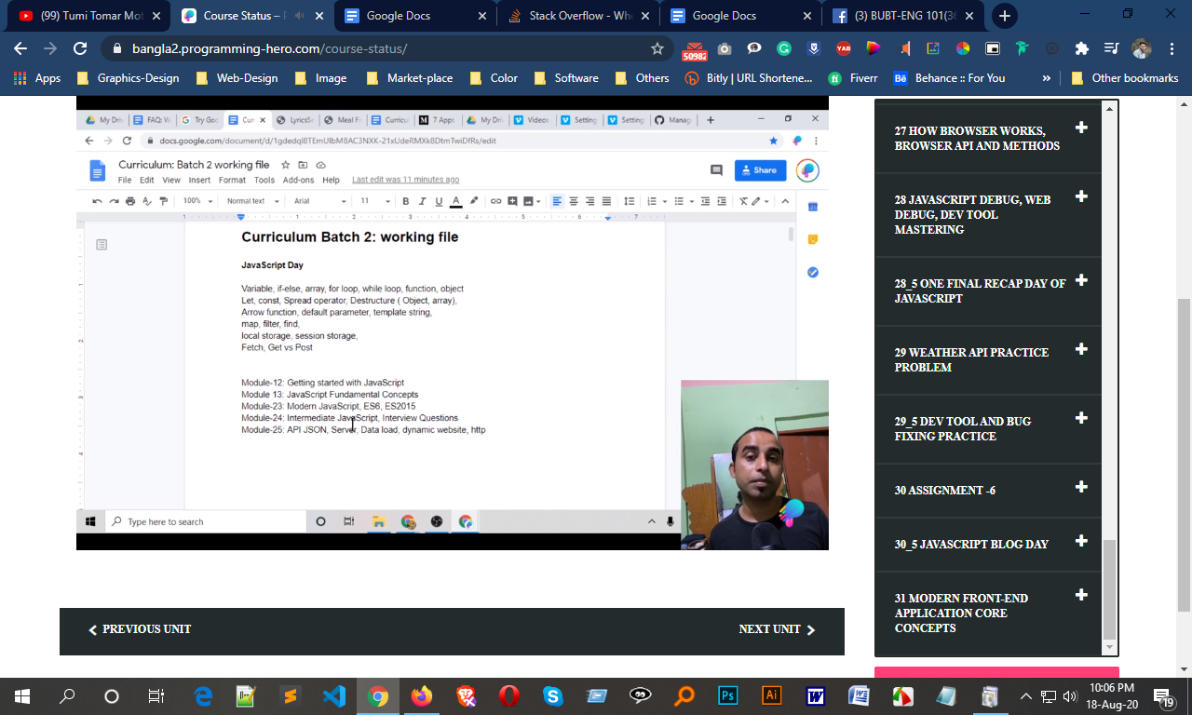

############# React install #####
git clone https://github.com/mdasif8393/programming
cd programming
ls
npm i
npm start
#### or
npx create-react-app my-app
cd my-app
npm start

